Background: Need to examine the efficacy of 4 psychosocial treatments (1=IDC, 2=CT, 3=SE, 4=GDC) for cocaine dependent patients.

Method: 487 patients were randomly assigned to the 4 treatment arms and were observed for 6 months. We need to perform the cross-sectional analysis at Month 3 and Month 6.

Goal: Does treatment predict the outcome (SIGHD17) at month 3 and month 6 and we need to compare results for both months.

**Outcome Variable: SIGHD17**

One of the most frequently used instruments for evaluating depression in adults, the questionnaire allows clinicians to assess the nature and severity of mood disorders in patient populations.

Each question examines a different symptom or aspect of depression, including mood, guilty feelings, suicidal ideation, insomnia, agitation, and somatic symptoms.

Each of the behaviorally anchored items is rated on either a 3- or 5-point scale and summed to obtain the total score. Scores greater than 24 are indicative of severe depression, and scores less than 7 are indicative of the absence of depression.

Reading of the Hamilton Depression Scale

The patient will be identified, and the depression level in the patients will be measure by the scales, and the results of reading during the following ranges will tell the story of depression in the patient:

1. No Depression (Zero to Seven)

* The range of the Hamilton Depression Scale scores from zero to seven, then the patient will be identified that the depression level in the patient will be equal to zero.

2. Mild Depression (Eight to Sixteen)

* The range of the Hamilton Depression Scale scores from eight to sixteen, then the patient will be identified that the depression level in the patient will be equal to mild depression.

3. Moderate Depression (Seventeen to Twenty-two)

* The range of the Hamilton Depression Scale scores from seventeen to twenty-three, then the patient will be identified that the depression level in the patient will be equal to moderate depression.

## 4. Severe Depression (Greater than twenty-four)

* The range of the Hamilton Depression Scale scores greater than twenty-four, then the patient will be identified that the depression level in the patient will be equal to severe depression.

**Orignal dataset looks like this:**

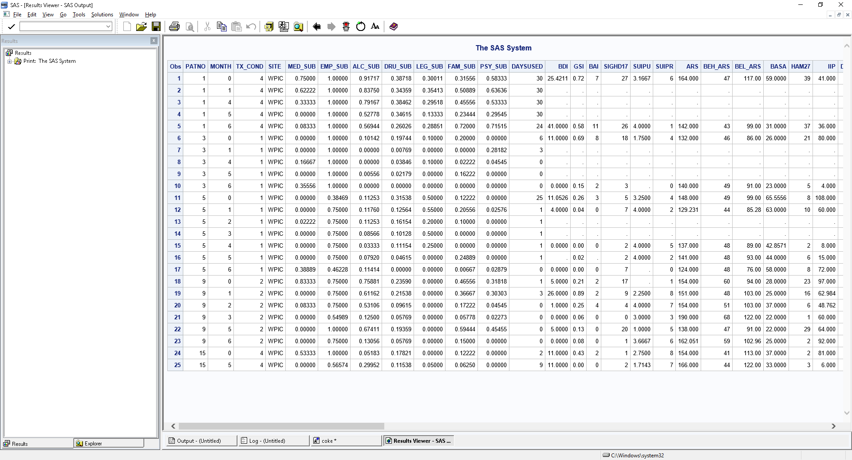

## Our Y variable will be sighd17: More the value means less effective is the treatment.

## Cross sectional analysis at Month 3:

## Eyeballing the data:

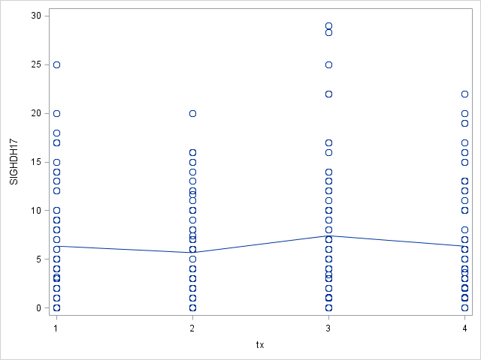

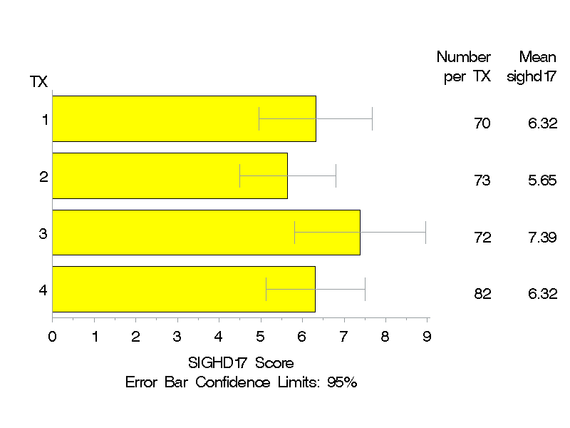

Looking at these graphs, we can say that the treatment 2 has lowest mean Hamilton depression score as compared to others.

Goodness of fit assumptions:

* 1. Normality is violated.
  2. HOV assumption met.
  3. Independence met.

Square root transformation is needed to correct the Normality. After square root transformation the normality is corrected as well as other assumptions are also met.

Effect of treatment on the Outcome (Hamilton depression score i.e. SIGHD17)

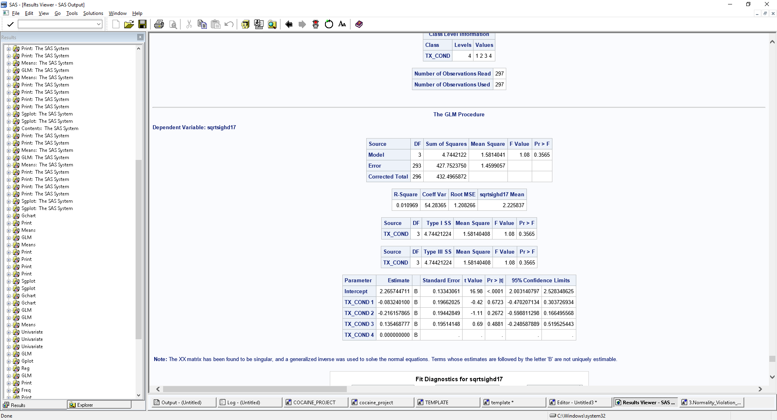

The p-value indicate that the four treatments are not significant different from one another in treating the depression.

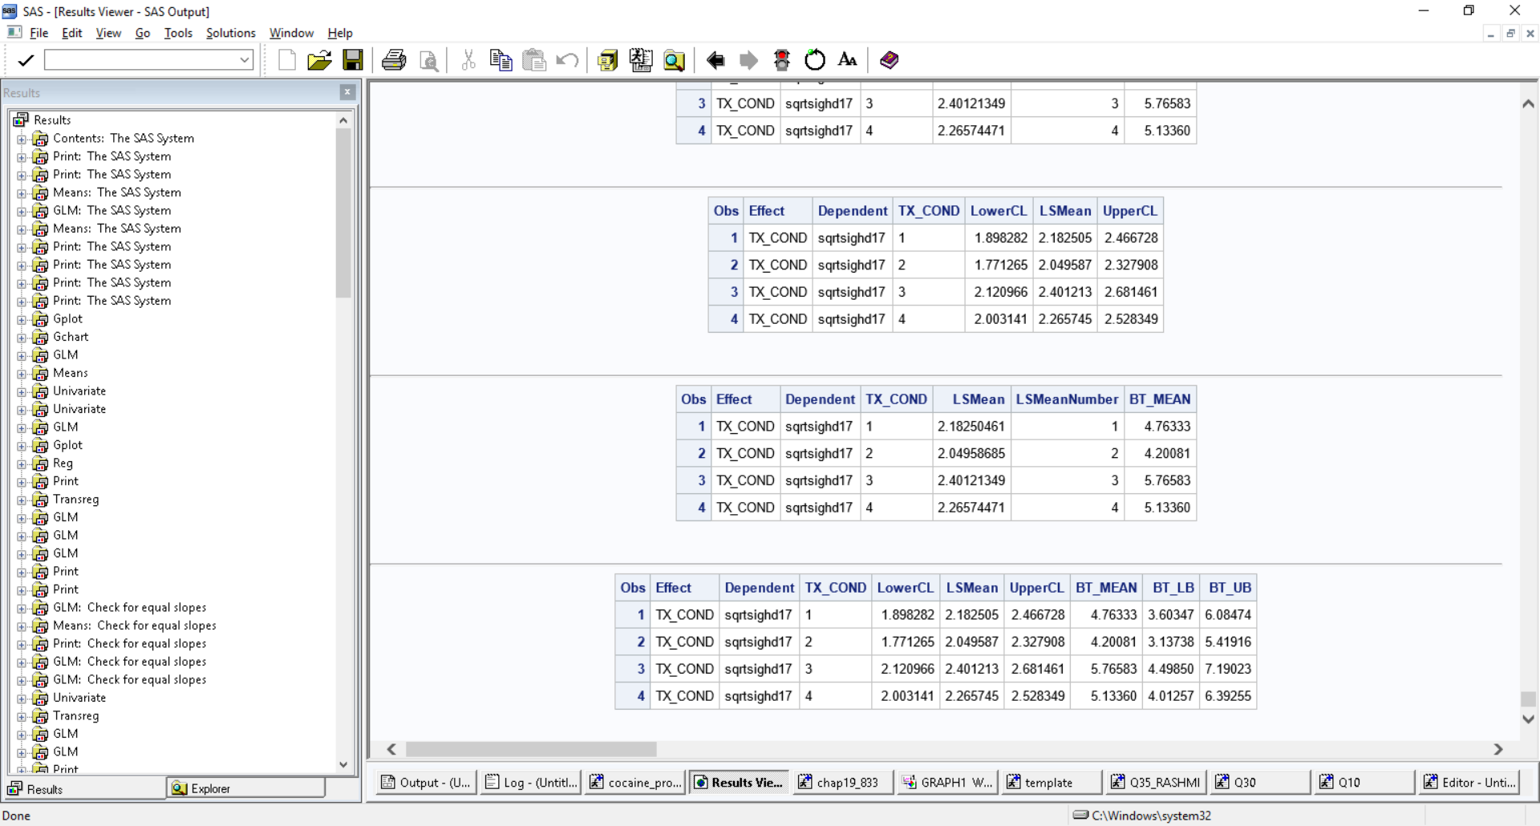

Including covariates into the model (PS_HAM17):

## What is a covariate?

Covariates are usually used in ANOVA and DOE. In these models, a covariate is any continuous variable, which is usually not controlled during data collection. Including covariates, the model allows you to include and adjust for input variables that were measured but not randomized or controlled in the experiment. Adding covariates can greatly improve the accuracy of the model and may significantly affect the final analysis results. Including a covariate in the model can reduce the error in the model to increase the power of the factor tests. Common covariates include ambient temperature, humidity, and characteristics of a part or subject before a treatment is applied.

For example, an engineer wants to study the level of corrosion on four types of iron beams. The engineer exposes each beam to a liquid treatment to accelerate corrosion but cannot control the temperature of the liquid. Temperature is a covariate that should be considered in the model.

In a DOE, an engineer may be interested in the effect of the covariate ambient temperature on the drying time of two different types of paint.

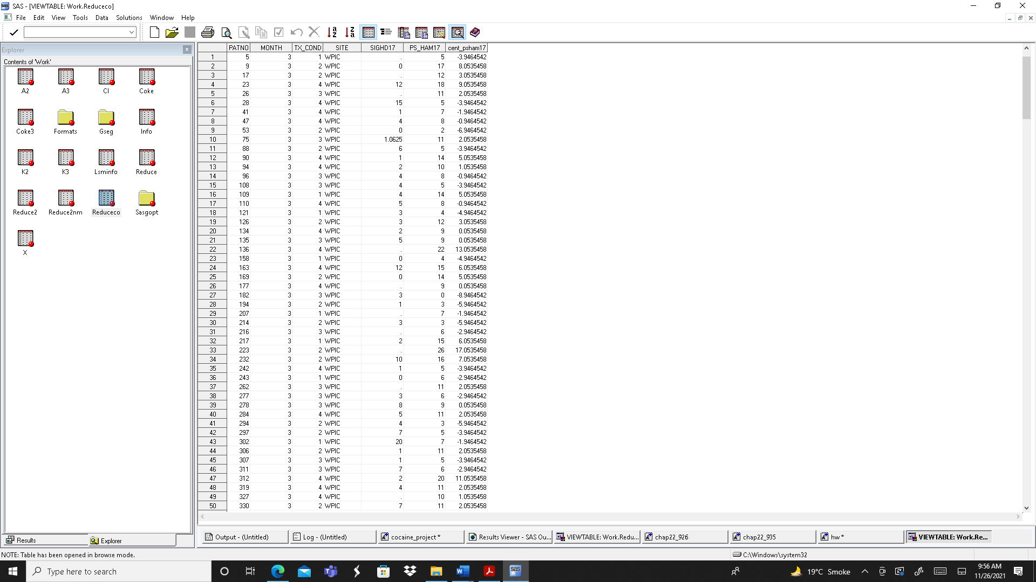

**Check for equal slope assumption:**

In the ANCOVA Model, there should not exist any interaction between the X and covariate (Z). If it exists, then it’s no longer a ANCOVA model.

The assumption is met so we can consider it as covariate

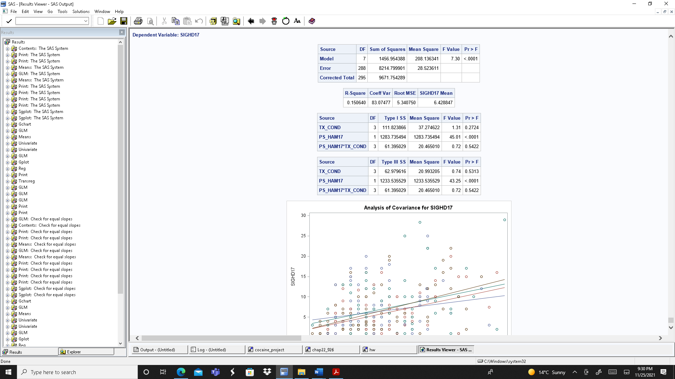

p-value of interaction is 0.5422 (do not reject null means no significant interaction)

We do not have sufficient evidence indicating the significant interaction between baseline Hamilton depression score and treatment level in the prediction of Hamilton depression score at Month 3.

We will assume the Consistency of slope assumption has been met.

**Normality assumption** is violated so we will try to transform it. We took the square root transformation. The variability indicated by the r square has improved by adding the covariate into the model. Also, we see that the baseline HD covariate in significant.

Treatments for the Hamilton depression score at month 3 are not significant different from one another.

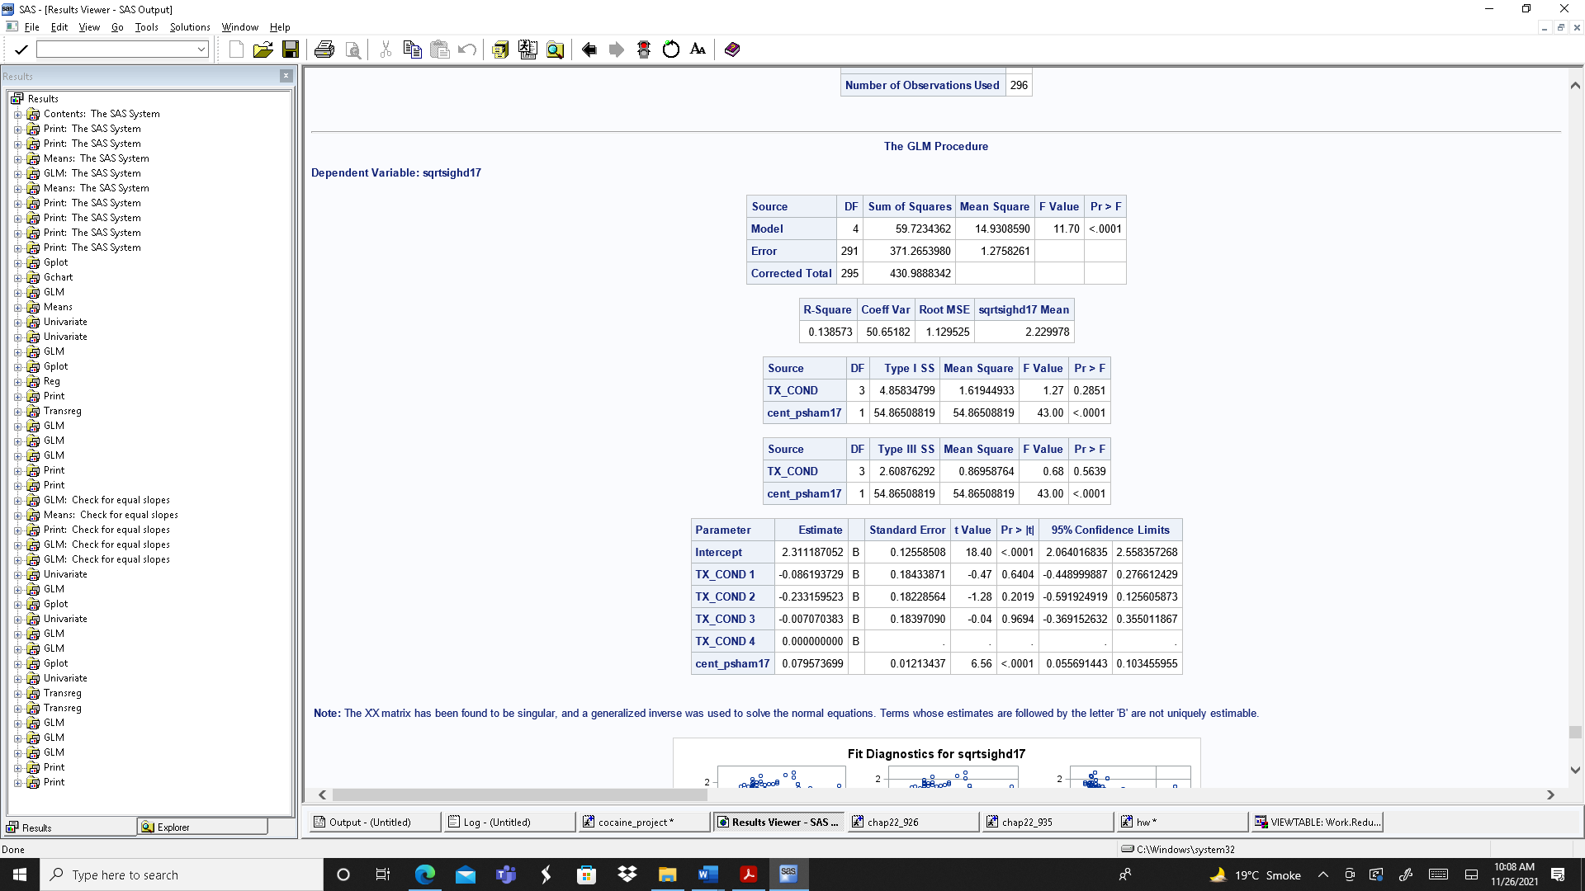

Results after backtransforming:

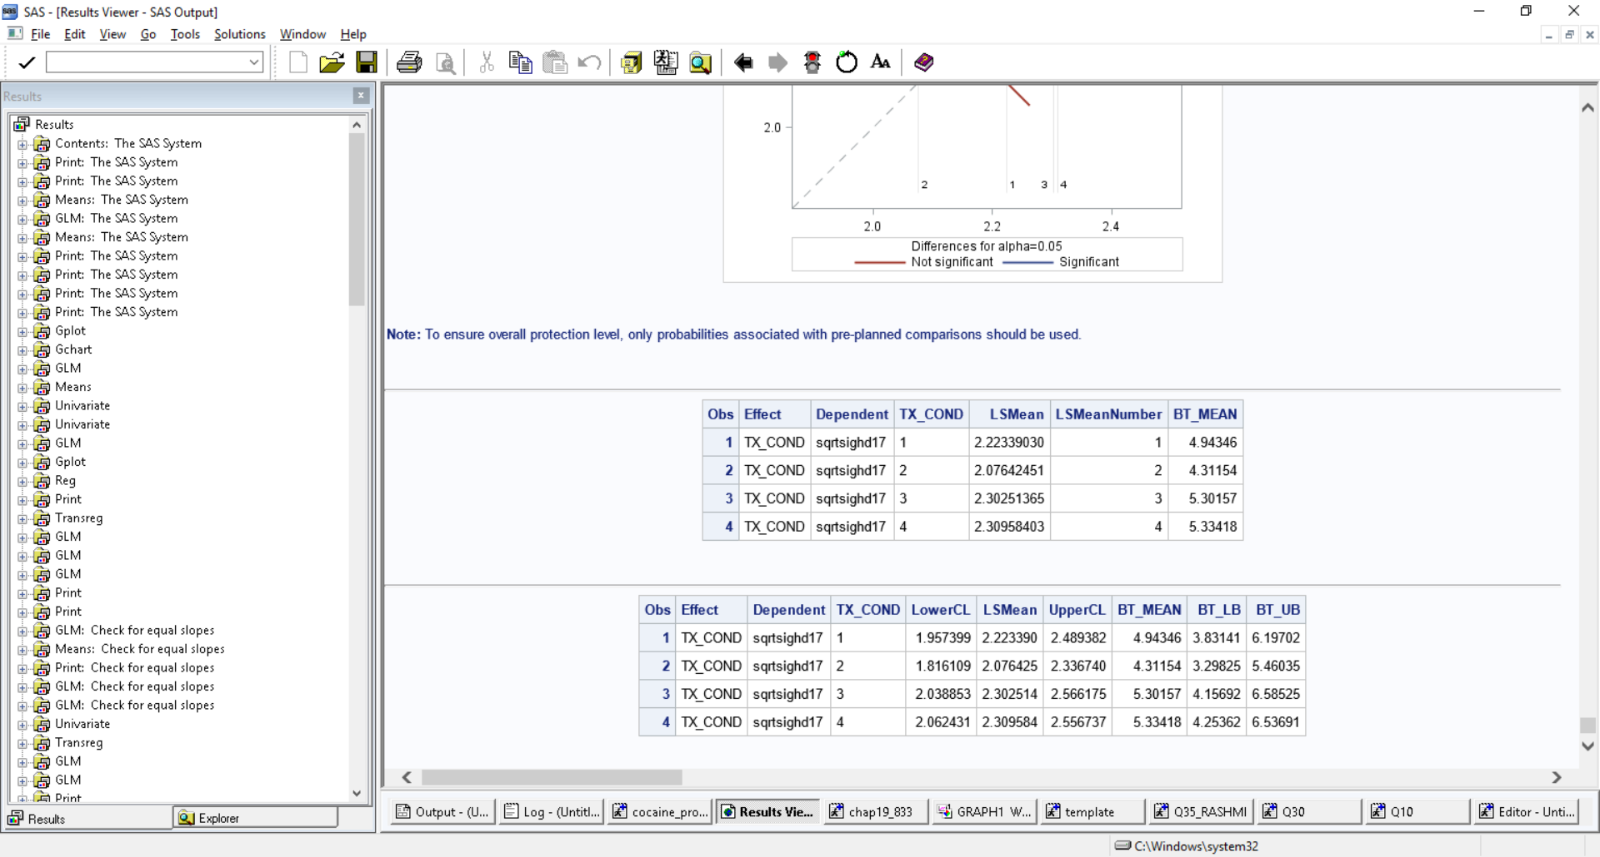

It indicates that the Hamilton depression score at Month 3 does not varies differently across different level of treatments. However, the Baseline Depression Score varies differentially across different level of treatments. Also adding the covariate in the model improved the R-square value. In the other words we can say that it reduced the unexplained variance of the outcome.

**Including the other variables into the model and 2/3-way interaction terms into the model:**

In ANOVA we have categorical predictor predicting the continuous outcome so we will include one of the following variables into the model to check the two-way interaction.

The categorical variables are:

GENDER

RACE

MAR_STAT

RACE

CRACK

COMPLETE

SITES

GTHS

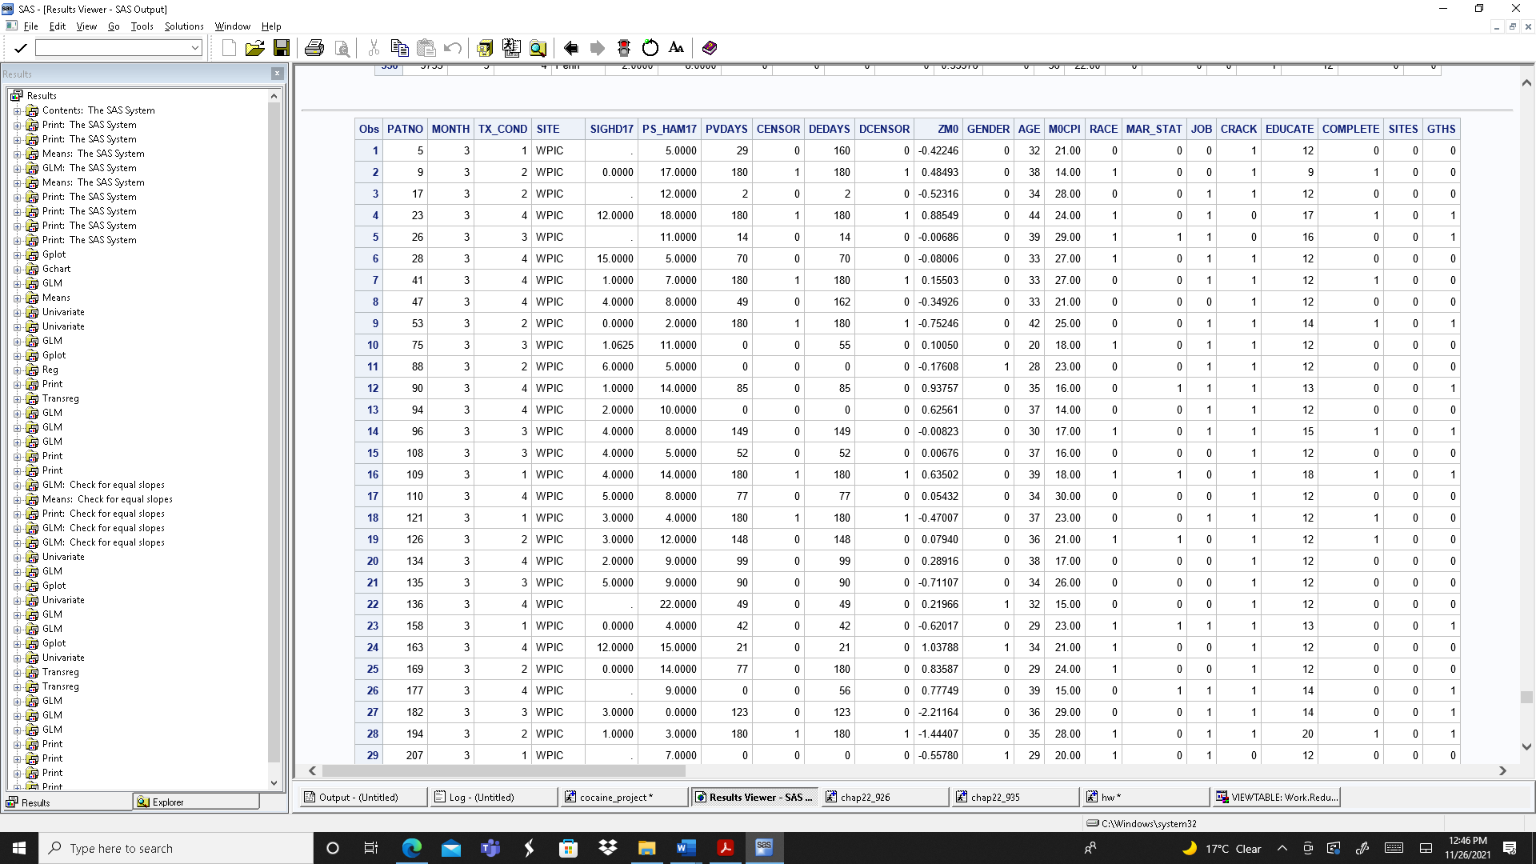

**Does the treatment depend on Marital status?**

I used Mar_stat variable as apriori and checked the two-way interaction of treatment and marital status.

Results are as follows:

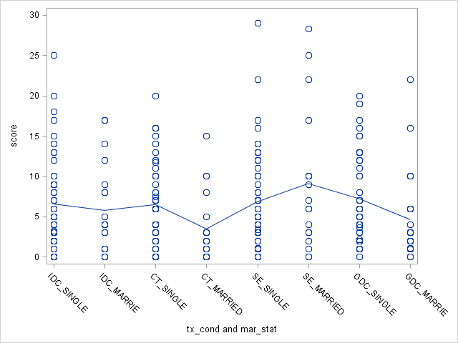

On eyeballing the data looks like the Treatment 2 i.e., Cognitive therapy and married have the lowest depression score.

Also looks like Married/ Cohabitating has the low Hamilton depression score than the person living alone except for the SE Treatment.

Output from the model:

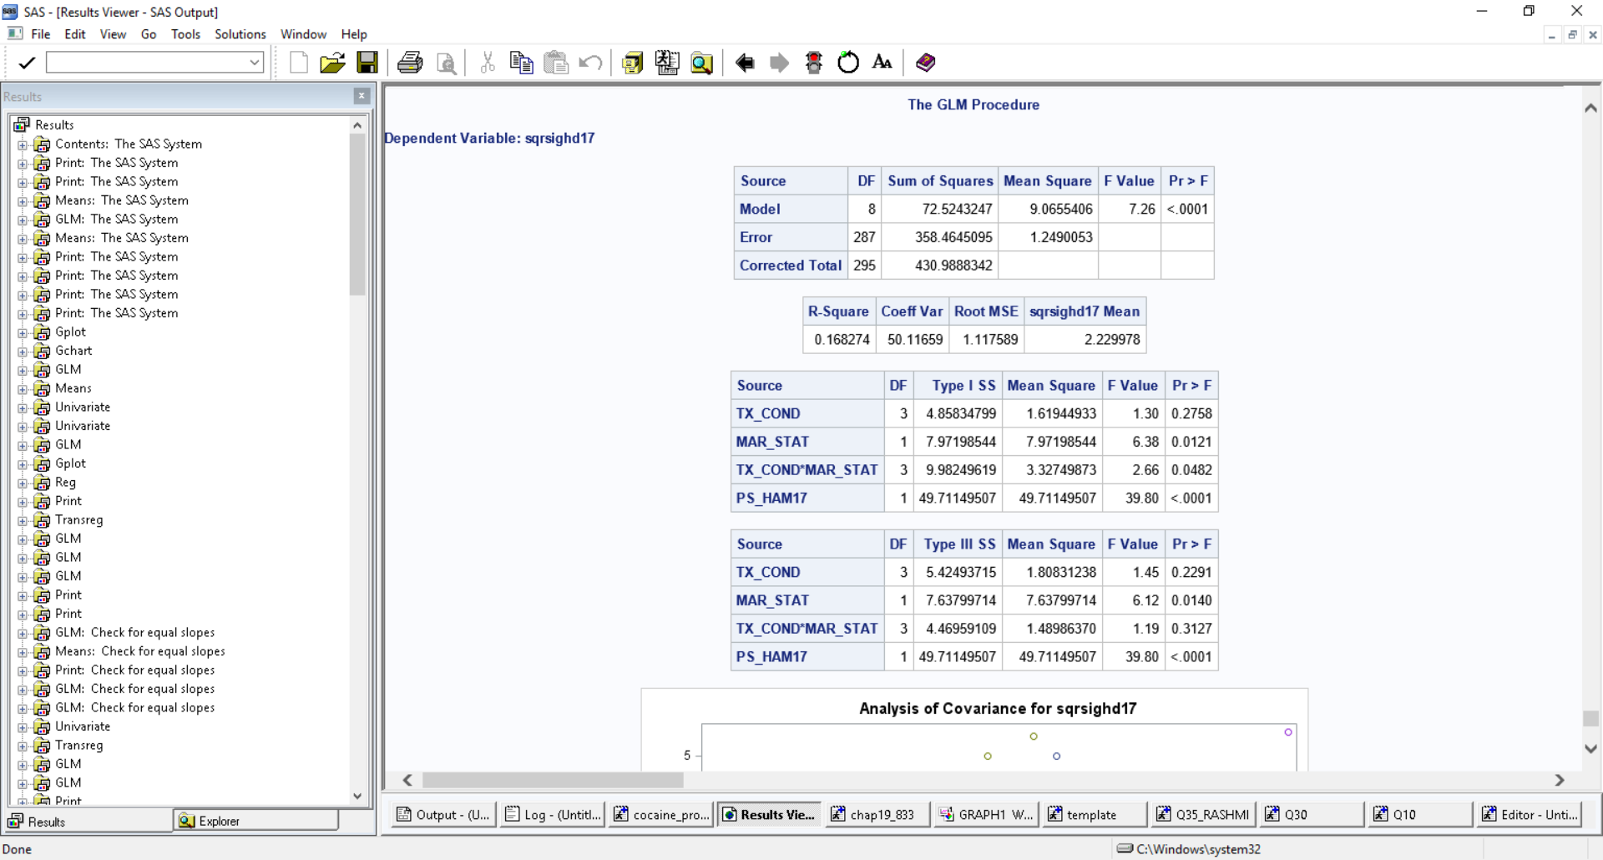

From the output it looks like the marital status and the baseline Hamilton depression score is significant.

Looking at the type3 values the interaction is not significant it means that the mean sighd17 score for person living alone and married does not varies differentially across different levels of treatment. It means treatment does not depend on the Marital status of person.

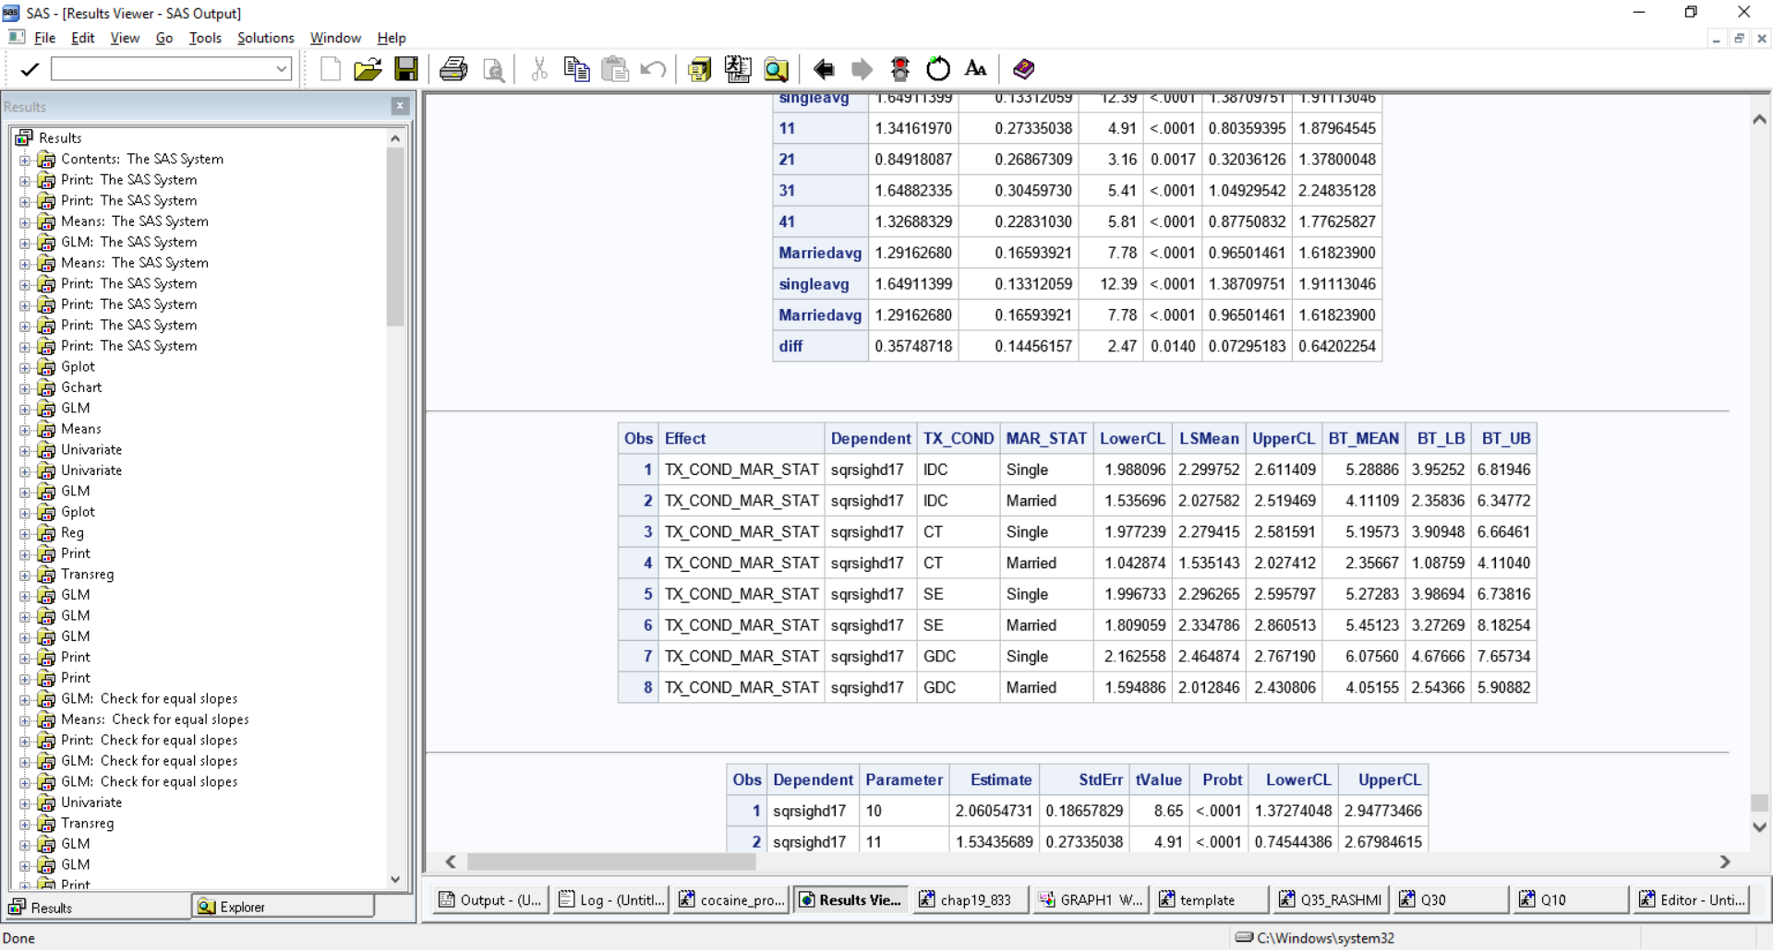

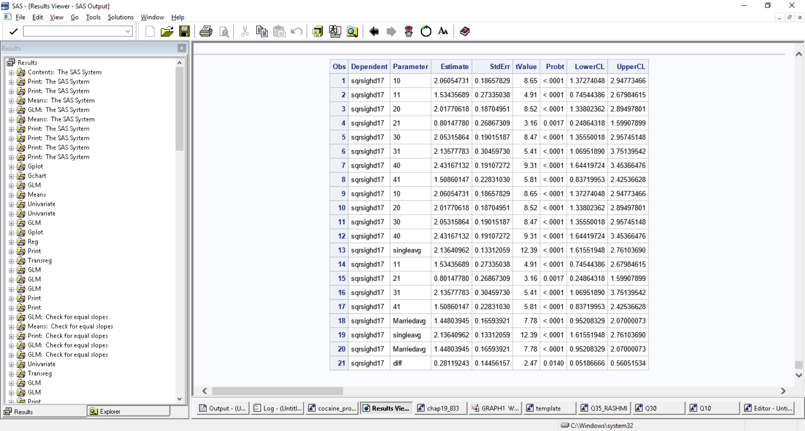

The person living alone has more SIGHD17 score than person who is married and that difference is significant.

Does the treatment depends on the GENDER?

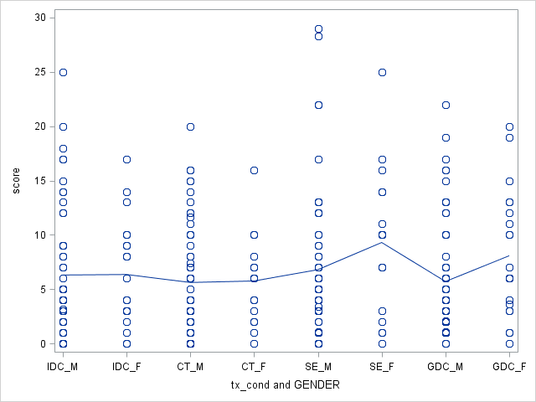

Looks like SE Female has more HD17 score.

Also for each treatment, female has more HD17 score compared to men.

Output:

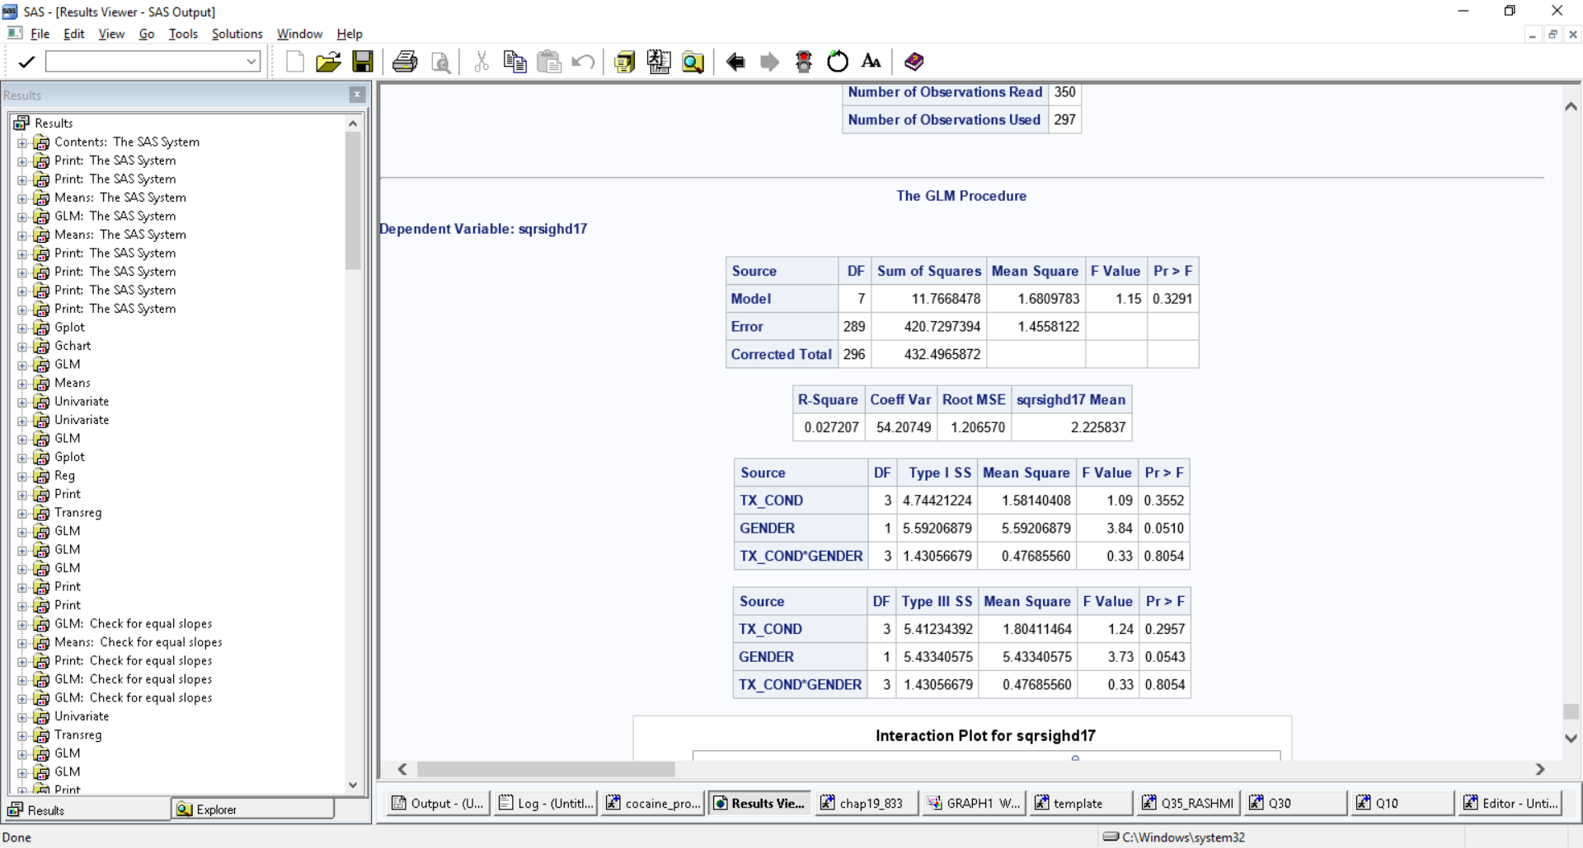

The gender is not significant in predicting the HD17 score.

The mean HD17 score for male, and female does not vary differentially across different level of treatment.

Does the gender affect the treatment?

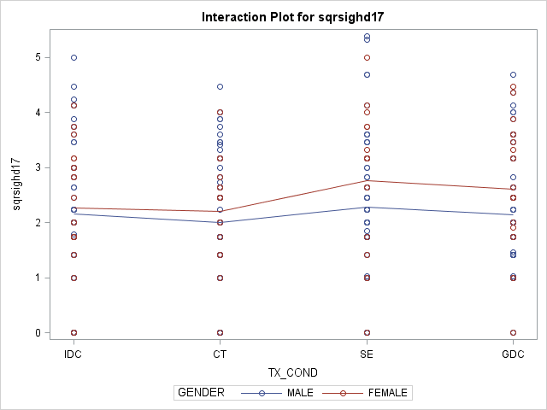

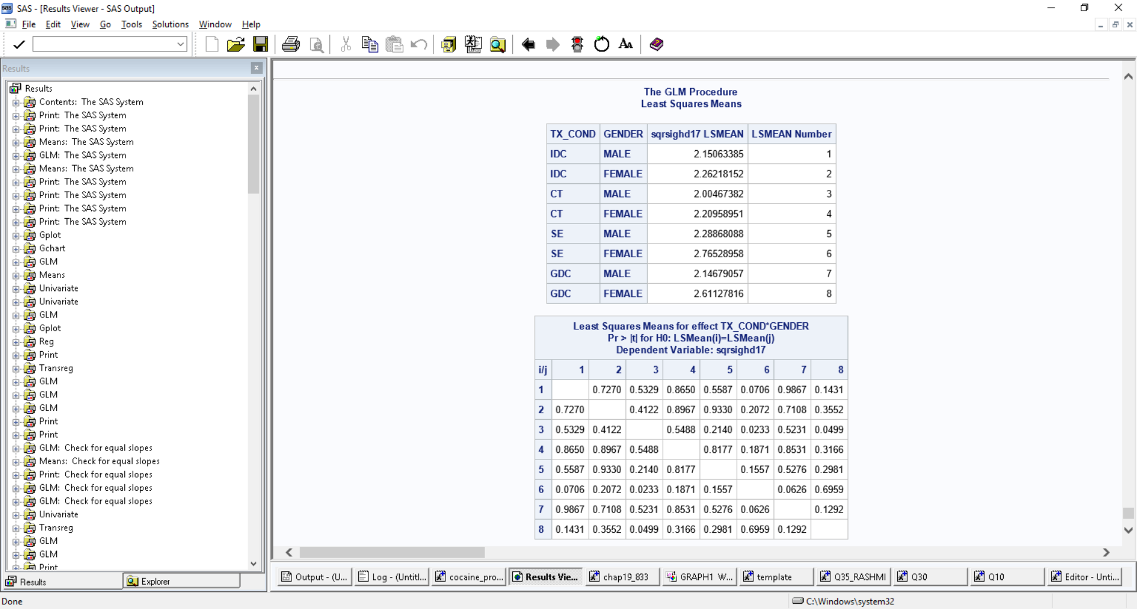

Also, the female for each treatment group has more estimated hd17 score but none of them is significant.

We performed contrast to estimate the difference in male and female across the four treatments. The results show that females have more estimated Hamilton depression score then men but that is not significant.

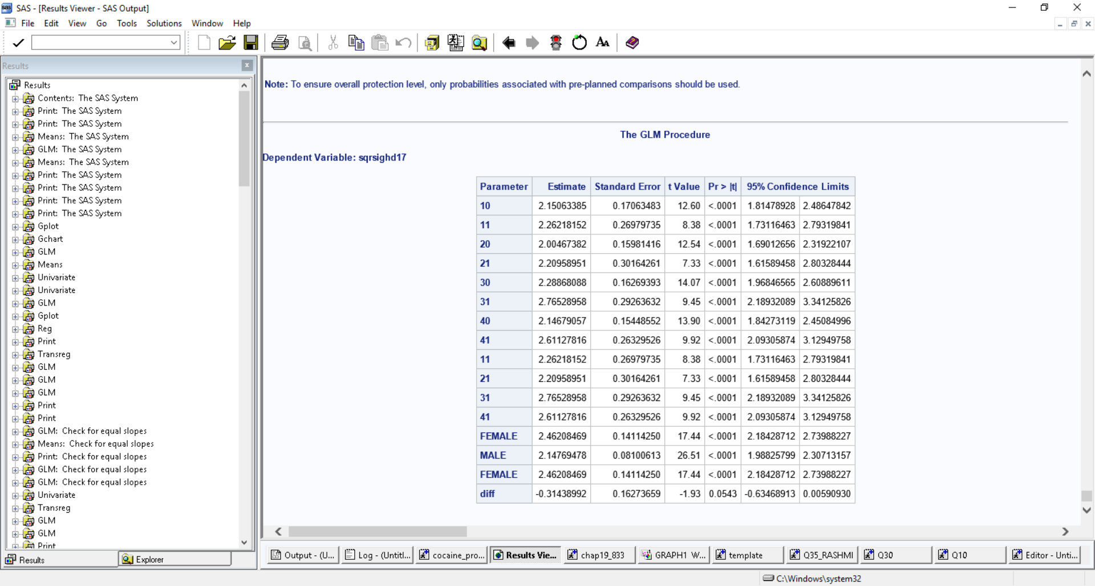

Including another variable to perform three-way interaction:

We selected the gender variable a priori to include into the model. Now our model has TX_COND, MAR_STAT and Gender variable.

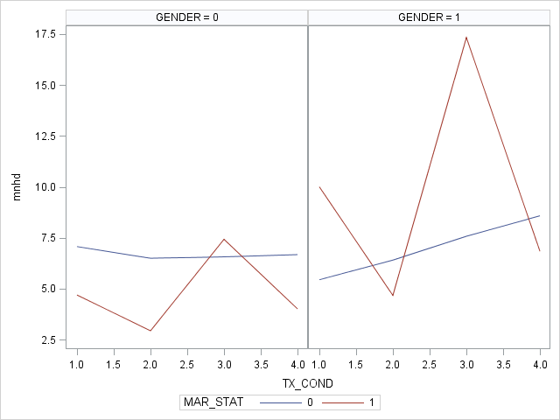

* The plot of marital status and Treatment for Gender=0 (Living alone) shows that the relationship is disordinal. Similarly, the plot of marital status and Treatment for Gender=1 (Married) shows that the relationship is disordinal.
* For TX=3, GENDER 1 AND MARITAL STATUS 1 we see highest Hamilton depression score.

Slice effect:

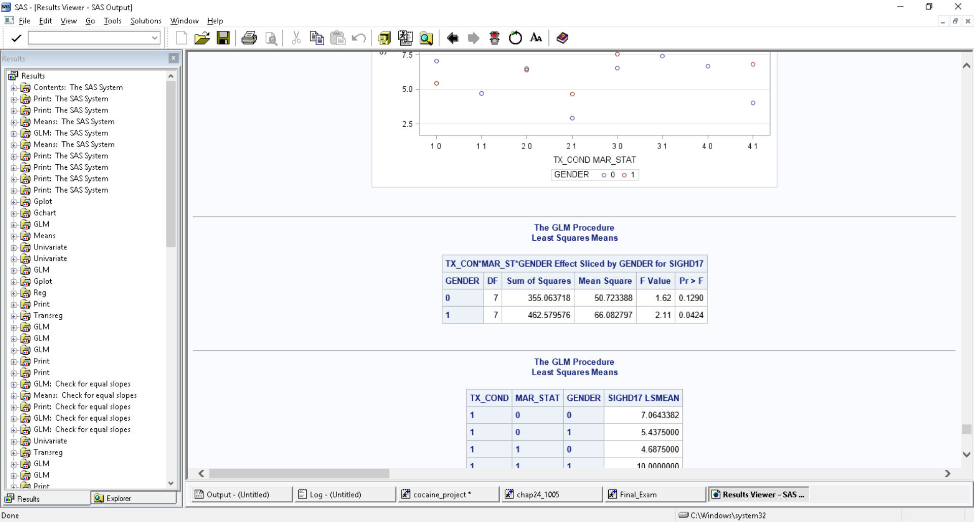



* For females (Gender=1) we see that the values at each level of treatment are significantly different from one another. However, for male, the values are not significantly different.

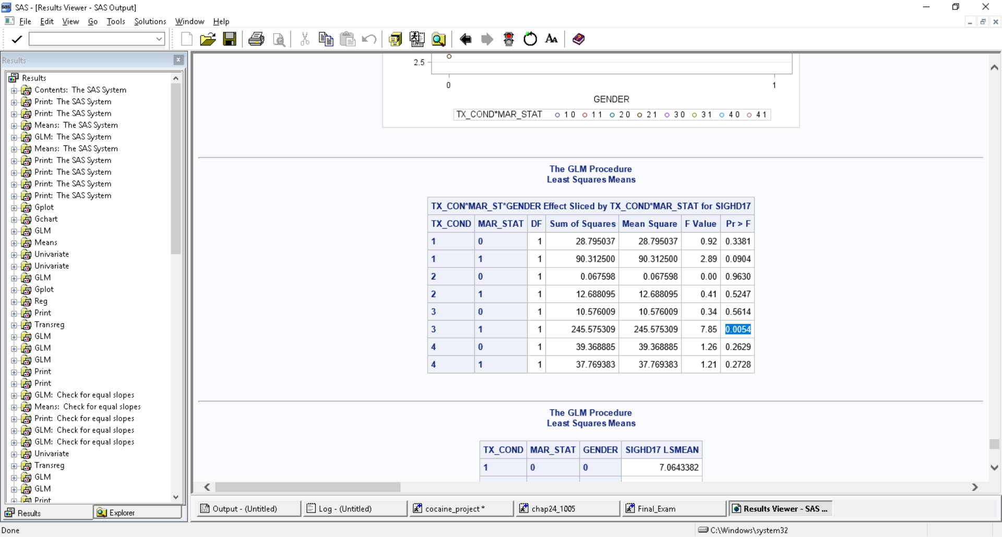



* For TX=3, GENDER 1 AND MARITAL STATUS 1 we see highest Hamilton depression score and that is significantly different from the male in treatment 3 and marital status 1

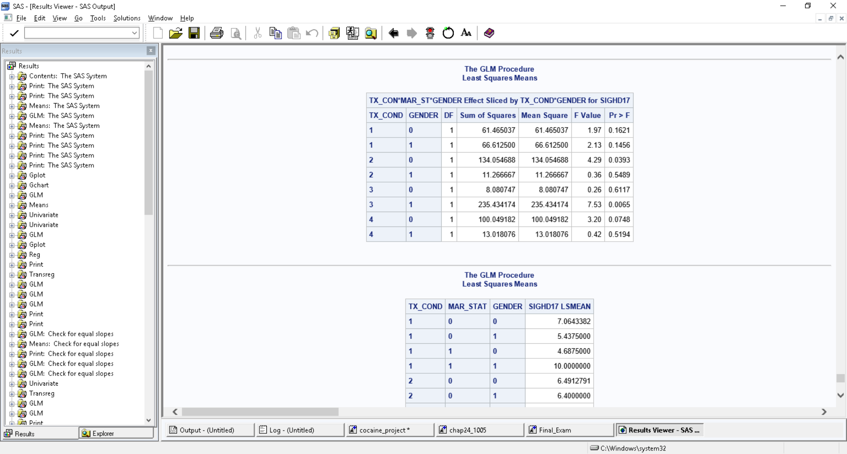





We see that the values of Hamilton depression score for gender=0 i.e., male and treatment =2 (Cognitive therapy) are significantly different from one another.

We see that the values of Hamilton depression score for gender=1 i.e., Female and treatment =3 (SE) are significantly different from one another.

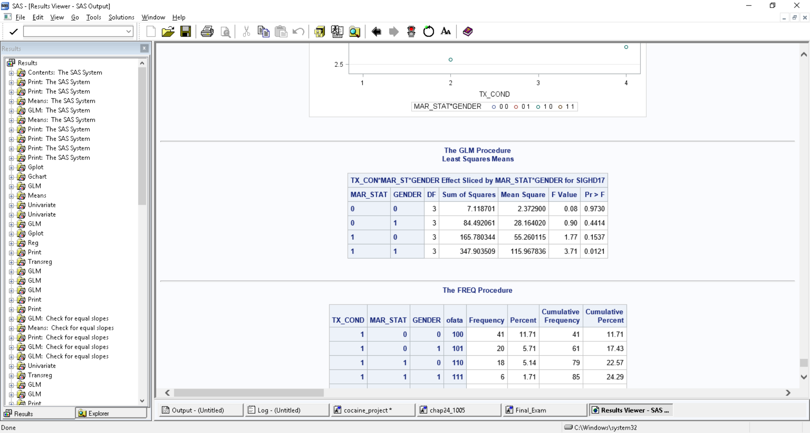



It shows that the values of HD for females varies significantly across different levels of treatment.

Fitting the model:

The square root transformation was performed to stabilize the normality. The output from the three-way interaction model is:

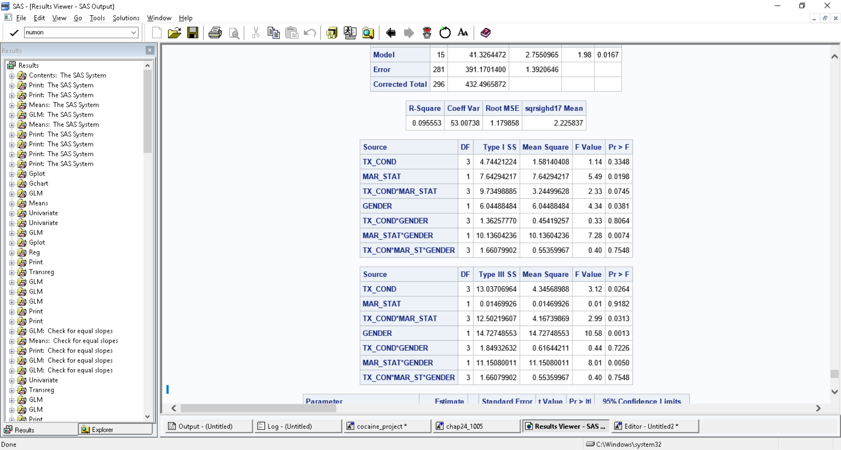

It shows that the three-way interaction is not significant. In the other words, on average difference in Y (SIGHD17 score on square root scale) varying as a function of Gender (Male and female) over Marital status (married and living alone) does not varies differential across different level of treatment groups.

Including covariate into the model:

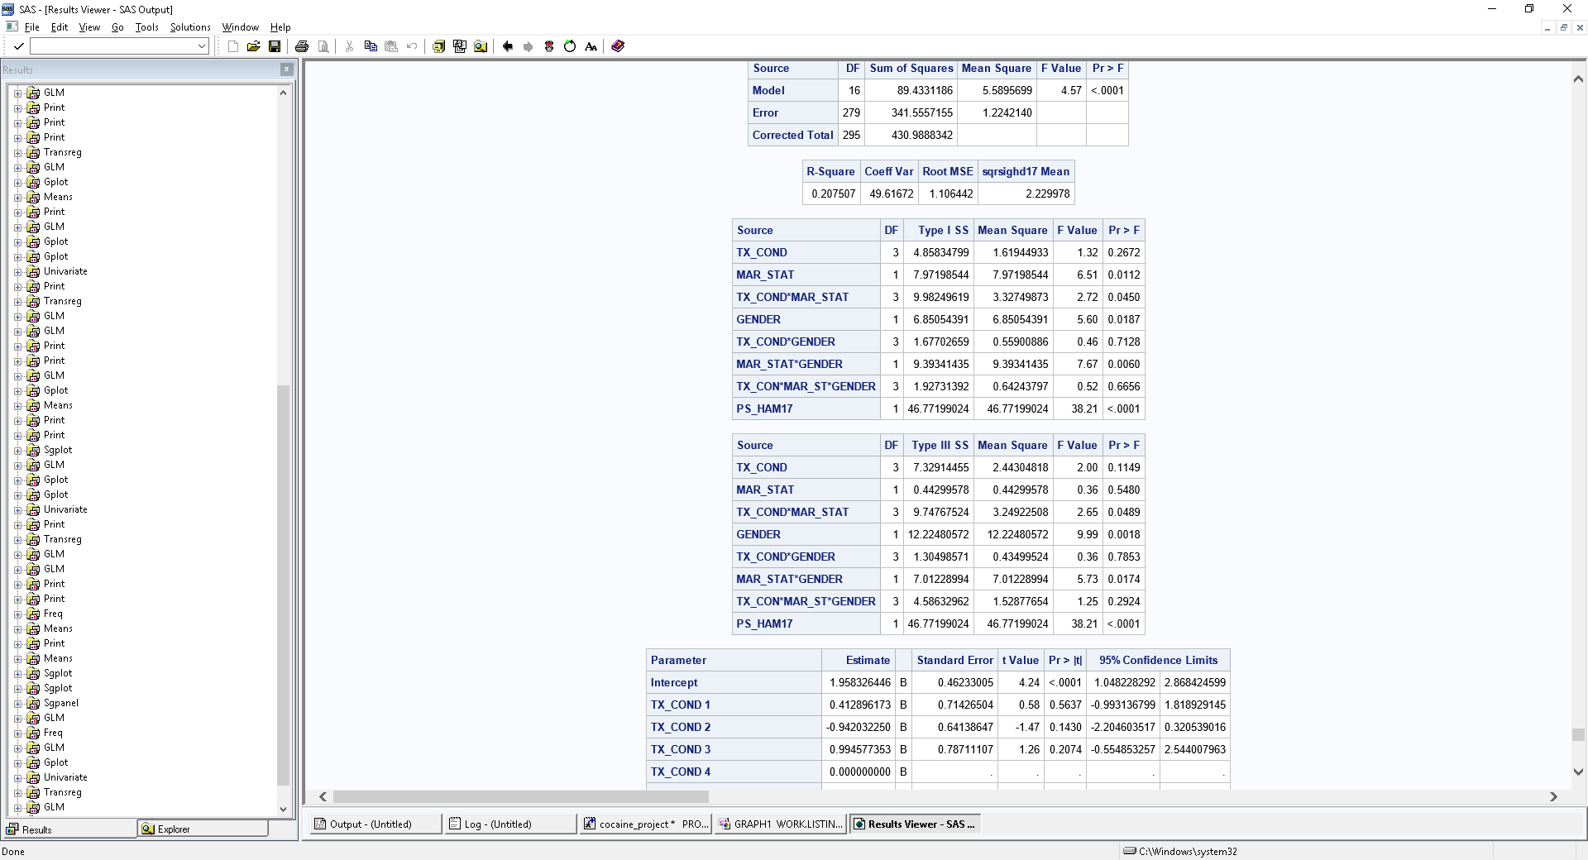

It shows that the three-way interaction is not significant. In the other words, on average difference in Y (SIGHD17 score on square root scale) varying as a function of Gender (Male and female) over Marital status (married and living alone) does not varies differential across different level of treatment groups.

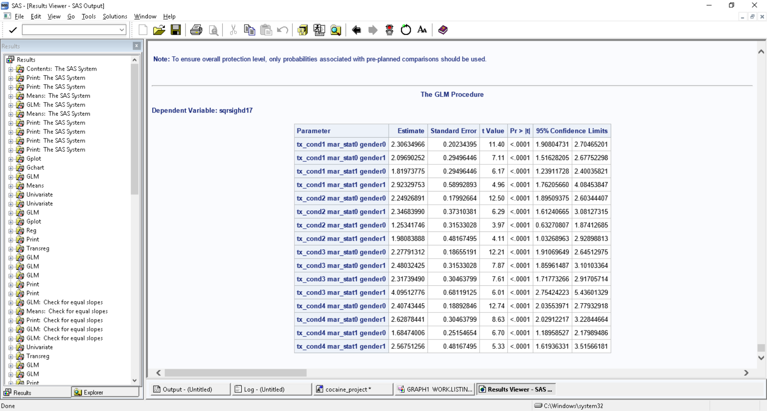

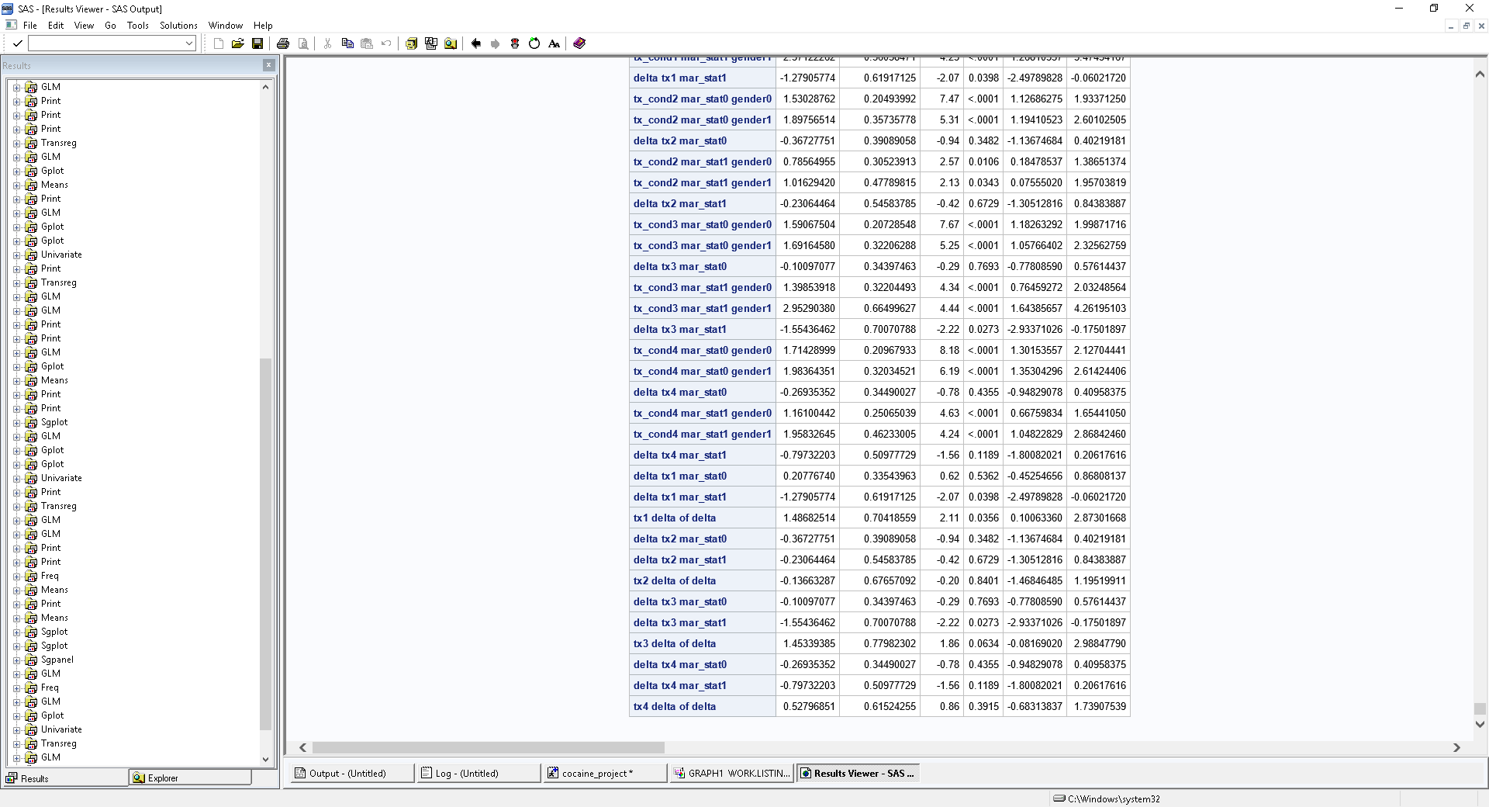

Including another variable to perform three-way interaction:

We selected the gender variable a priori to include into the model. Now our model has TX_COND, MAR_STAT and Gender variable.



* The plot of marital status and Treatment for Gender=0 (Living alone) shows that the relationship is disordinal. Similarly, the plot of marital status and Treatment for Gender=1 (Married) shows that the relationship is disordinal.
* For TX=3, GENDER 1 AND MARITAL STATUS 1 we see highest Hamilton depression score.

Slice effect:





* For females (Gender=1) we see that the values at each level of treatment are significantly different from one another. However, for male, the values are not significantly different.





* For TX=3, GENDER 1 AND MARITAL STATUS 1 we see highest Hamilton depression score and that is significantly different from the male in treatment 3 and marital status 1







We see that the values of Hamilton depression score for gender=0 i.e., male and treatment =2 (Cognitive therapy) are significantly different from one another.

We see that the values of Hamilton depression score for gender=1 i.e., Female and treatment =3 (SE) are significantly different from one another.





It shows that the values of HD for females varies significantly across different levels of treatment.

Fitting the model:

The square root transformation was performed to stabilize the normality. The output from the three-way interaction model is:



It shows that the three-way interaction is not significant. In the other words, on average difference in Y (SIGHD17 score on square root scale) varying as a function of Gender (Male and female) over Marital status (married and living alone) does not varies differential across different level of treatment groups.

Including covariate into the model:



It shows that the three-way interaction is not significant. In the other words, on average difference in Y (SIGHD17 score on square root scale) varying as a function of Gender (Male and female) over Marital status (married and living alone) does not varies differential across different level of treatment groups.

